Early warning of MIB episode based on gene abundance and expression in drinking water reservoirs
Tengxin Cao^{1,6,7}, Jiao Fang¹, Zeyu Jia^{3,1}, Yiping Zhu⁴, Ming Su^{1,2,7,*}, Qi Zhang⁵, Yichao Song⁴, Jianwei Yu^{1,2,7}, Min Yang^{2,1,7,*}
1. Key Laboratory of Drinking Water Science and Technology, Research Center for Eco-Environmental Sciences, Chinese Academy of Sciences, P.O. Box 2871, Beijing, 100085.
2. National Engineering Research Center of Industrial Wastewater Detoxication and Resource Recovery, Research Center for Eco-Environmental Sciences, Chinese Academy of Sciences, P.O. Box 2871, Beijing, 100085.
3. Yangtze Eco-Environment Engineering Research Center, China Three Gorges Corporation, Beijing, 100038.
4. Shanghai Chengtou Raw Water Co. Ltd., Beiai Rd. 1540, Shanghai, 200125.
5. Institute of Hydrobiology, Chinese Academy of Sciences, No. 7 Donghu South Road, Wuchang, Wuhan, 430072.
6. Sino-Danish College, University of Chinese Academy of Sciences, Beijing, 100049.
7. University of Chinese Academy of Sciences, Beijing, 100049.
* Corresponding Author: Min Yang (yangmin@rcees.ac.cn)

Supplementarty Material
Figures and/or tables are provided below as the supplemenatary evidences to the main text.

Fig. 1 Map and sampling sites of QCS Reservoir

Fig. 2 Bathymetry of QCS Reservoir

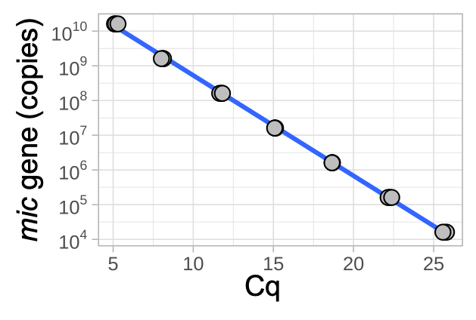
Fig. 3 Standard curve of mic gene quantification. The correlation between mic gene and Cq was: $Cq=−3.4537lg\left(c_{mic}\right)+40.13\left(R^{2}=0.999,p<0.0001\right)$

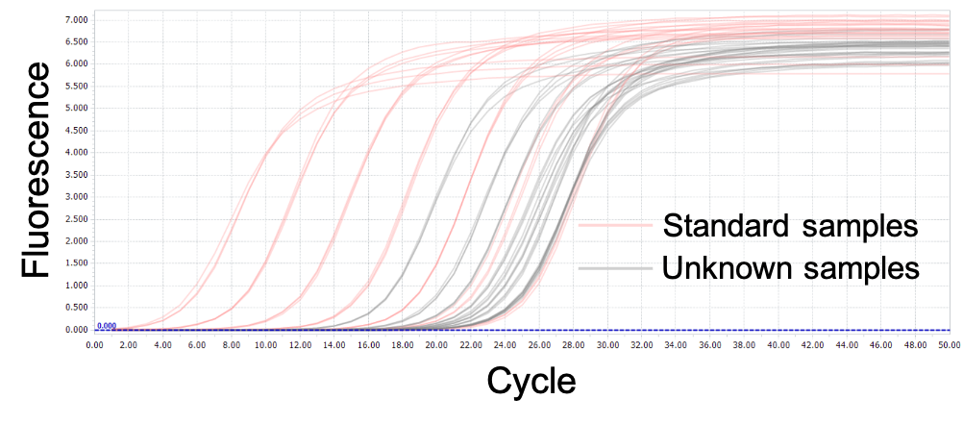
Fig. 4 Amplification curves of mic qPCR

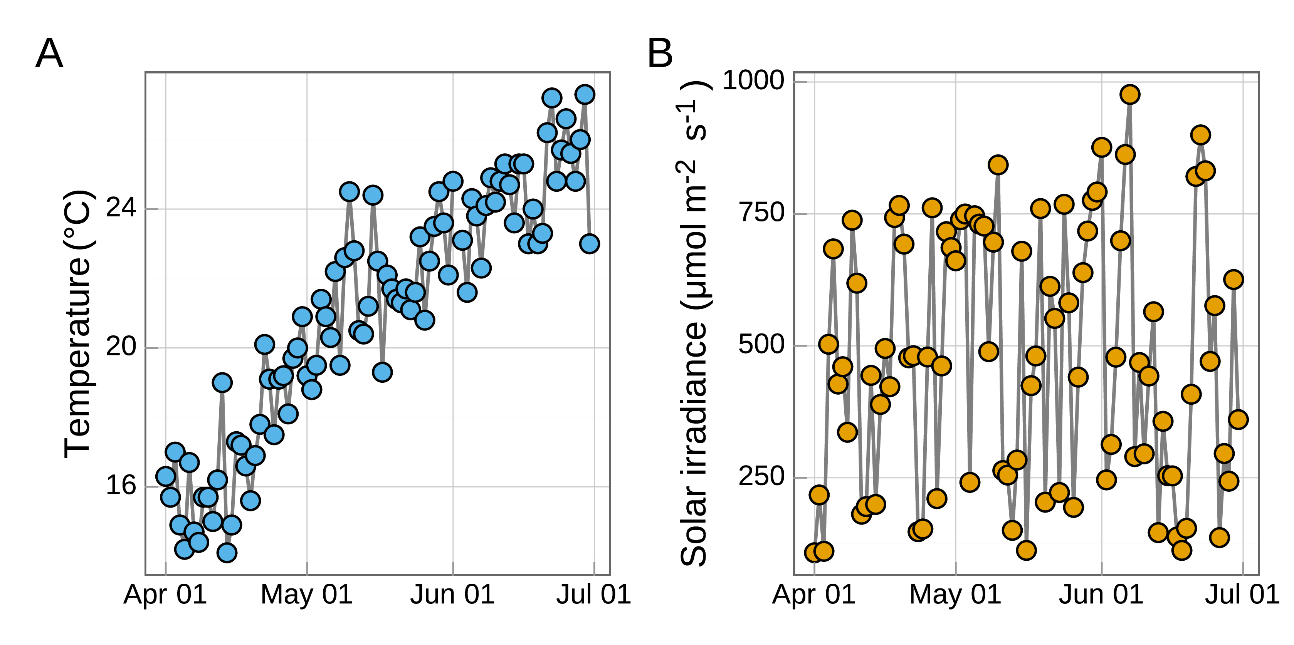
Fig. 5 Dynamics of water temperature and light irradiance during the MIB episode in QCS Reservoir in 2021

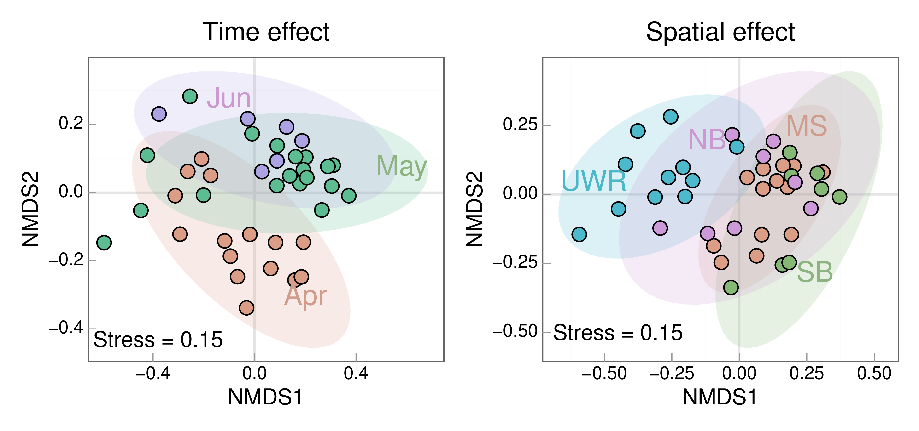
Fig. 6 Dynamics of phytoplankton communities in QCS Reservoir in 2021

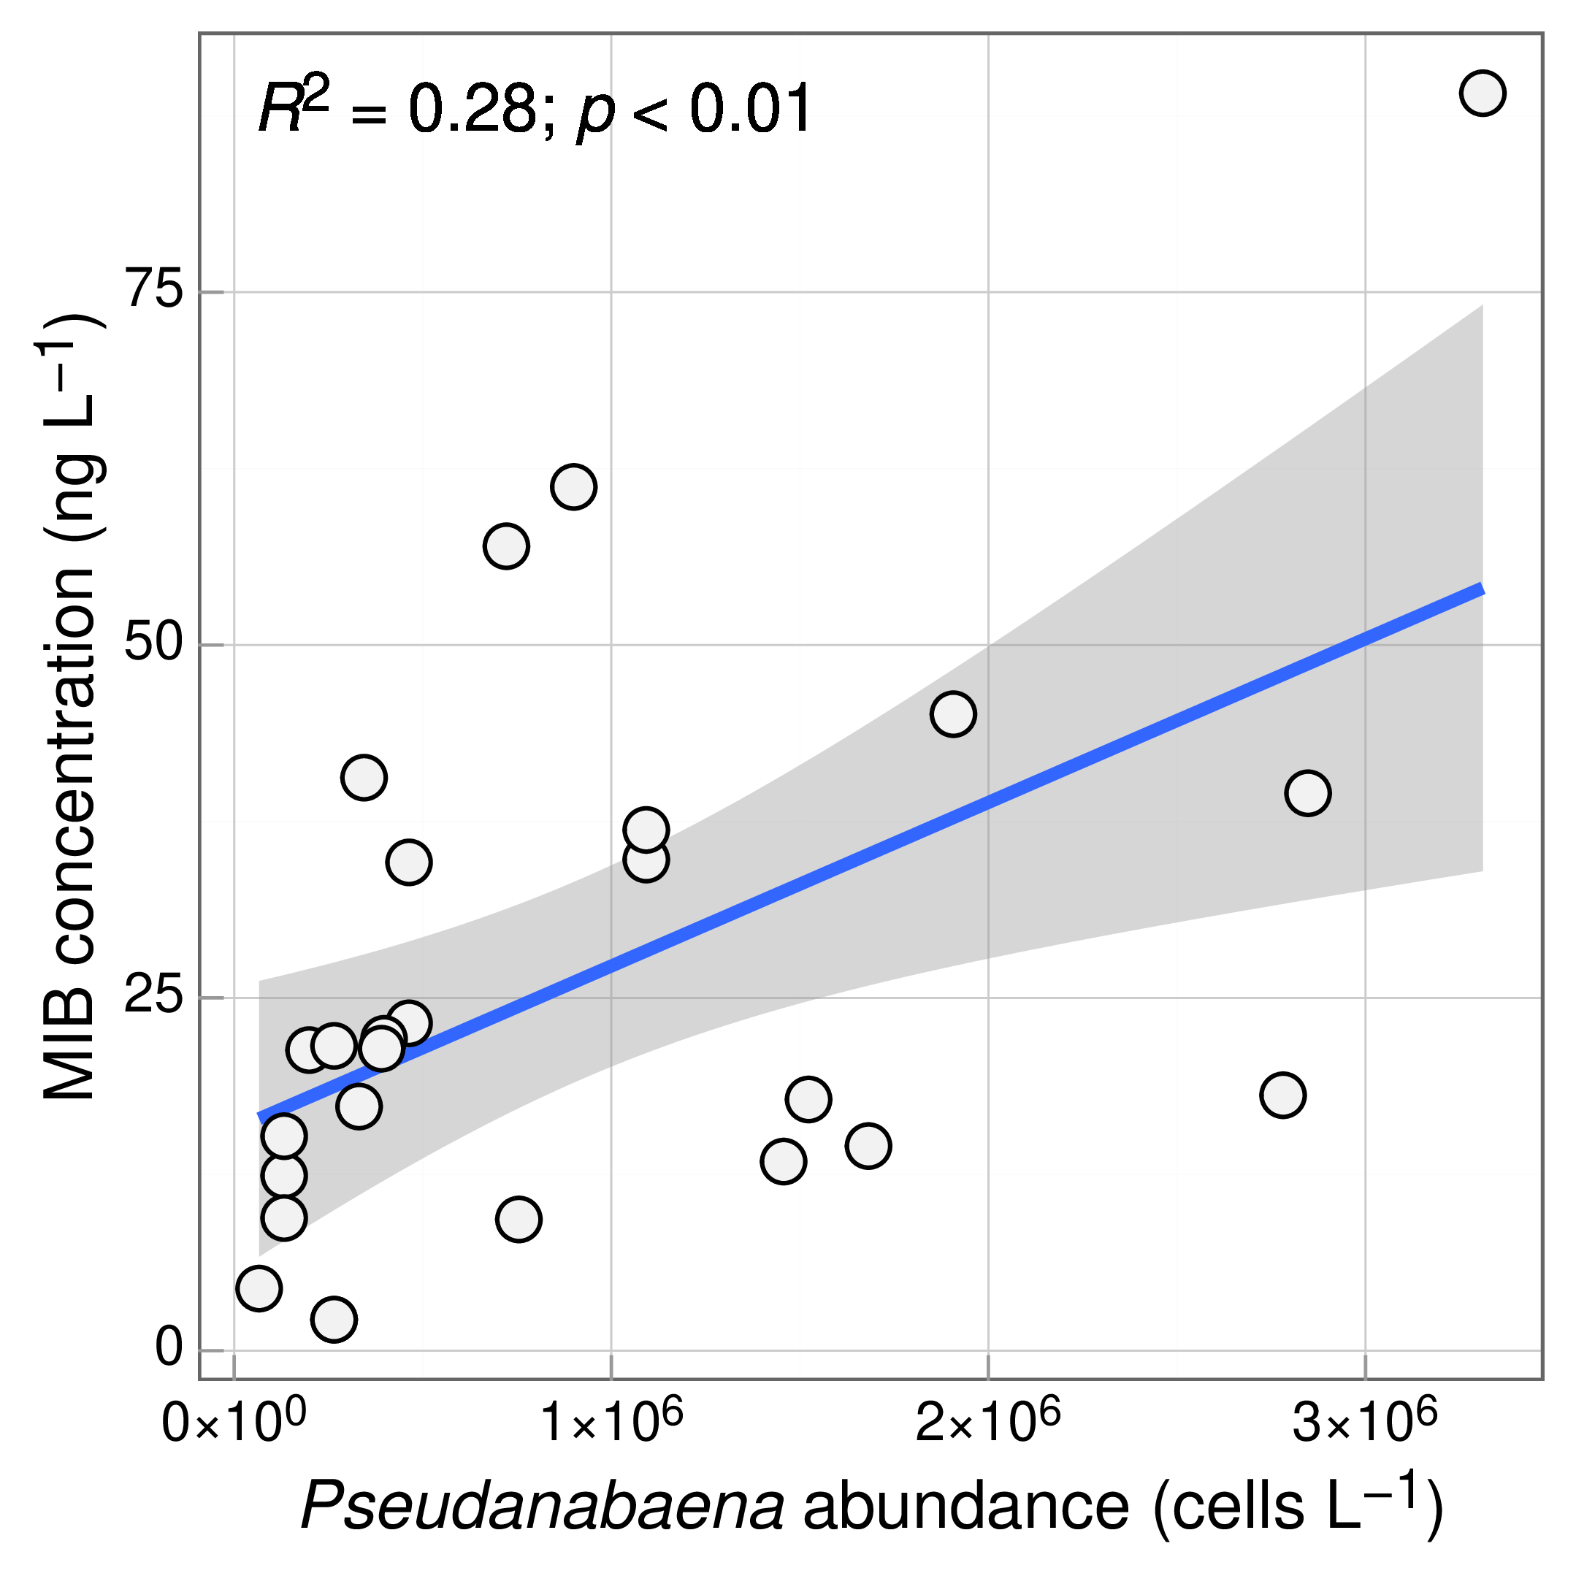
Fig. 7 Correlation between MIB concentration and Pseudanabaena cell density

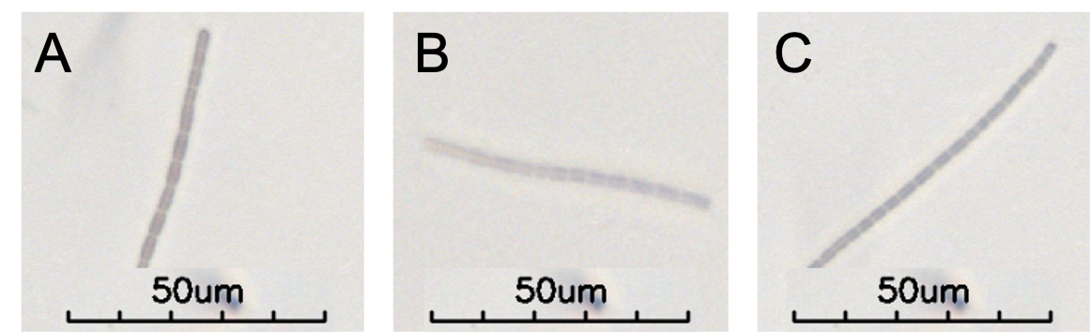
Fig. 8 Images of isolated Pseudanabaena strains (A: P. cinerea; B: P. limnetica; C: P. catenate)

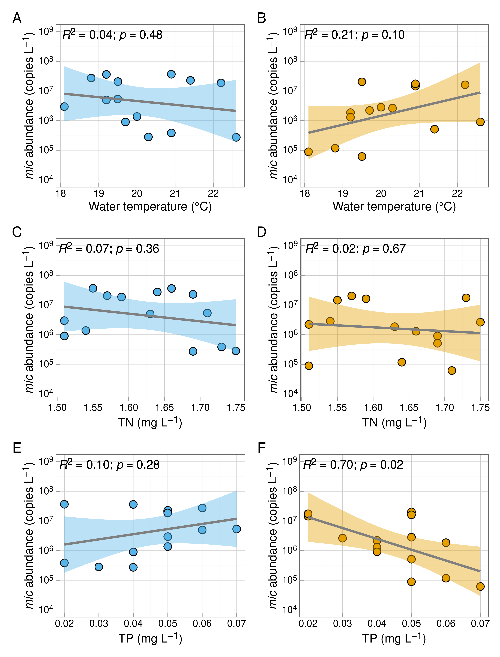
Fig. 9 Correlation between DNA or RNA abundance of mic gene and water temperature (A, B), TN (C, D), and TP (E, F), respectively, in QC10 during the MIB episode

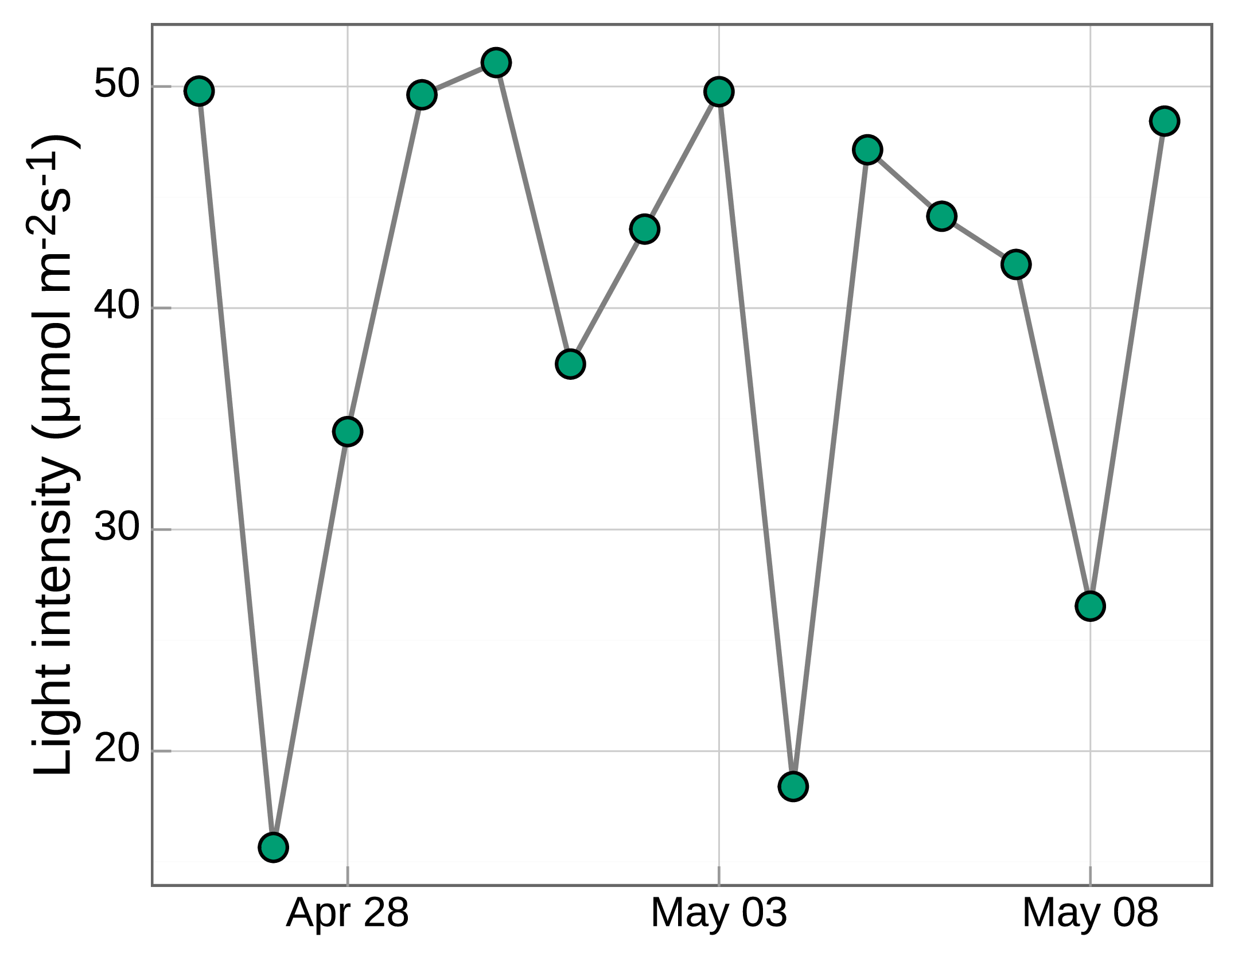
Fig. 10 The mean light intentisy of the underwater column in QCS Reservoir during the MIB episode in 2021

Fig. 11 Temperature dynamics in QCS Reservoir

Fig. 12 Dynamics of MIB concentration and DNA abundance of mic gene in JZ Reservoir (A) and LH Reservoir (B), respectively.
Table 1 Distribution of sampling sites in 4 regions of QCS Reservoir
Sampling sites | Regions
QC05 | Upstream river water (URW)
QC17, QC12, QC10 | North branch (NB)
QC14, QC15, QC23, QC11 | South branch (SB)
QC18,QC22,QC25,QC09,QC08,QC19, | Middle section (MS)
QC20,QC02,QC07,QC06,QC01

Table 2 Three stains of Pseudanabaena isolated from QCS Reservoir. Taxonomic classification was identified by 16S rRNA gene sequencing and blasted with NCBI database
Isolation ID | Identification | Similarity | MIB | Accession number
1 | P. cinerea | 1.0000 | + | ON571433
2 | P. limnetica | 0.9986 | - | ON553403
3 | P. catenate | 0.9961 | - | ON571434

